24.-

>> x= -10:0.2:10;

>> y= -10:0.2:10;

>> z= -10:0.2:10;

>> [X,Y,Z]= meshgrid(x,y,z);

>> Q= -X.^2+Y.^2-Z.^2-1;

>> H=patch(isosurface(X,Y,Z,Q,0));

>> set(H,'FaceColor','red','EdgeColor','red');

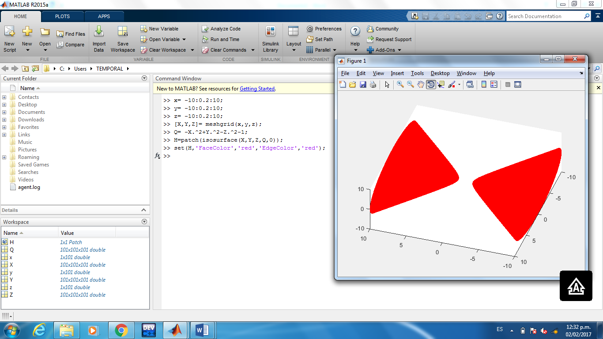

11.-

>> y= -10:0.2:10;

>> z= -10:0.2:10;

>> [Y,Z]= meshgrid(y,z);

>> X= Y.^2+4.\*(Z.^2));

X= Y.^2+4.\*(Z.^2));

|

Error: Unbalanced or unexpected parenthesis or bracket.

>> X= Y.^2+4.\*(Z.^2);

>> surfc(Y,Z,X)

>>

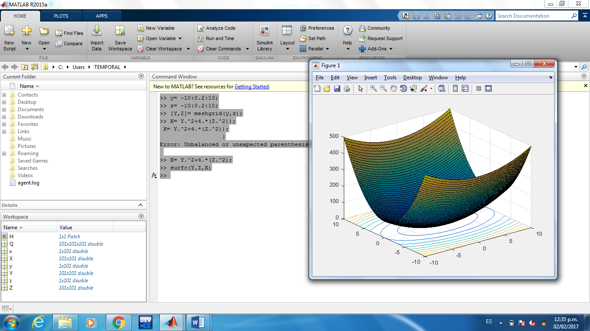

13.-

>> y= -10:0.2:10;

>> z= -10:0.2:10;

>> [Y,Z]= meshgrid(y,z);

>> X= sqrt(Y.^2+4\*(Z.^2));

>> surfc(Y,Z,X)

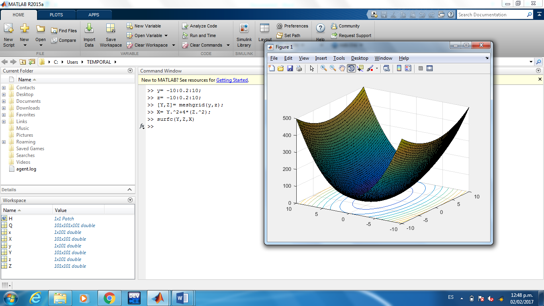

15.-

>> x= -10:0.2:10;

>> y= -10:0.2:10;

>> z= -10:0.2:10;

>> [X,Y,Z]= meshgrid(x,y,z);

>> Q= -X.^2+4\*(Y.^2)-Z.^2-4;

>> H=patch(isosurface(X,Y,Z,Q,0));

>> H=patch(isosurface(X,Y,Z,Q,0));

>> set(H,'FaceColor','red','EdgeColor','red');

